22-06-2022

Daniel Duarte & Daniel Tomás

|CMAs - Systems Consultants LDA |

**Wages Receipts Splitter**

Test Scenes

***Index***

***Scenes*** 2

1º Scene: 2

2º Scene**:** 3

4º Scene**:** 4

5º Scene**:** 5

6º Scene**:** 5

7º Scene**:** 5

8º Scene**:** 6

9º Scene: 6

10º Scene: 6

11º Scene: 7

12º Scene: 7

13º Scene: 7

# ***Scenes***

## 1º Scene:

In this Scenario the client will send a request with the 2 following files:

**Preview: Nifs&Passwords Json File**

**Preview: WagesReceipts PDF File**

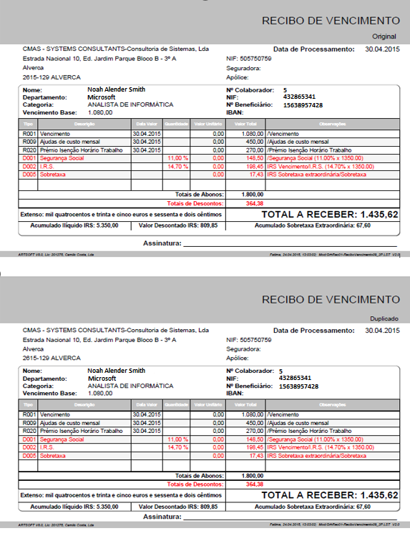

In this case the Wages Receipts file contains 8 receipts of persons, 2 of which are composed by 2 pages, adding to a total of 10 pages. The Passwords file contains 8 NIFs, 1 for each person, with the corresponding password.

If the files are all correct the program will send the files to the corresponding person's folder in alfresco

Example of a folder where one of the files is sent:

## 2º Scene**:**

In this Scenario we will see wat happen when we give the program a list of NIFs bigger than the quantity of receipts in the pdf.

**Input:** Wages Receipts File containing 3 Receipts, 1 of which contains 2 pages. The Nifs & passwords file contains nifs and passwords of 6 persons.

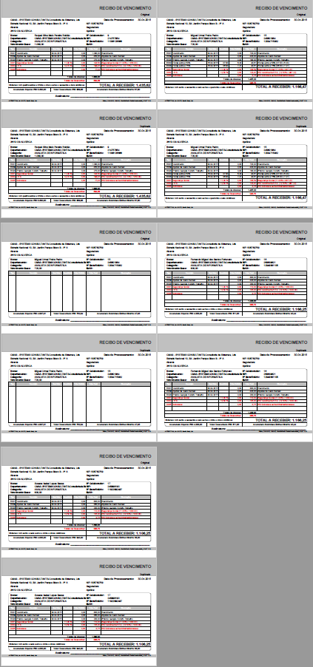

**Preview: Nifs&Passwords File**

**Preview: WagesReceipts File**

The program will only send to alfresco the 3 people who have NIFF in the Passwords file and the others are not sent because they do not exist in the Waige Recipt PDF file

**Output:**



**Message:**

## 4º Scene**:**

None of the NIFs in the password file match the NIFs in the wage receipts file.

The program splits the wage receipts by the worker NIF but the NIFS in Nifs&Passwords File don´t match to any of the receipts.

**Preview: Nifs&Passwords File**

The program won't be able to do any splits and will give the following error:

## 5º Scene**:**

Is given an empty password file.

The Program tries to Read the password file, but the file is empty, so the program won’t be able to split and will give the following error:

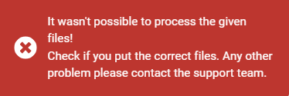

## 6º Scene**:**

The given a pdf file that is not a wages receipts document.

Since it isn’t a wage receipts file any split will be preform, and the program will show the following error:

## 7º Scene**:**

Is given a password file with just 3 NIFs with the corresponding password and a pdf file with 8 workers wage’s receipts

**Preview: Nifs&Passwords Filev**

The Program make the split, protect and send to alfresco just the existing NIFs

**Output:** The program outputs the 3 receipts

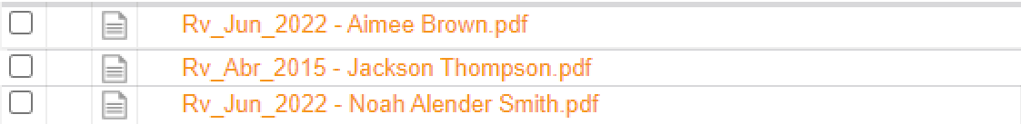

## 8º Scene**:**

When the program is sending the pdf files to alfresco if the folder don´t exits the alfresco repository it will give the following:

## 9º Scene:

Another scene is, if the client, when sending a request, forgets to send the password file along with the pdf or forget to send any file, the following error will appear:

## 10º Scene:

If the customer forgets to send the pdf file when sending the request, this error will appear:

## 11º Scene:

When the client makes the API request, if he sends the JSON passwords file with the incorrect format or don’t give a JSON File,

it will give the following error:

## 12º Scene:

If the client, when giving a request, gives the password file with the wrong NIF with less than 9 characters,

this error will appear:

## 13º Scene:

If the customer, when giving a request, if the receipt file is not a pdf, the following error will appear:

